Report about 2048

The screen shot in the game:

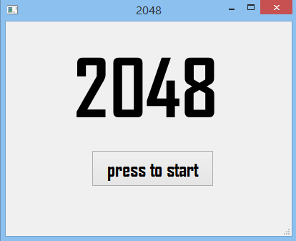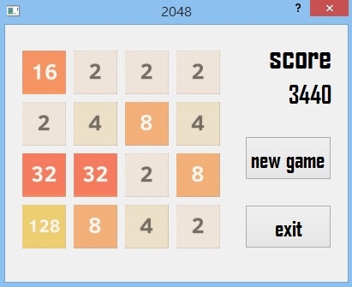

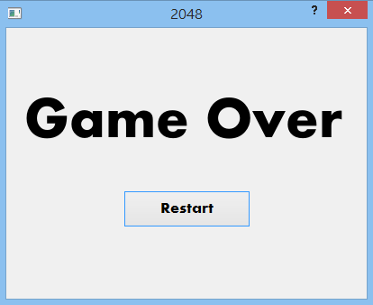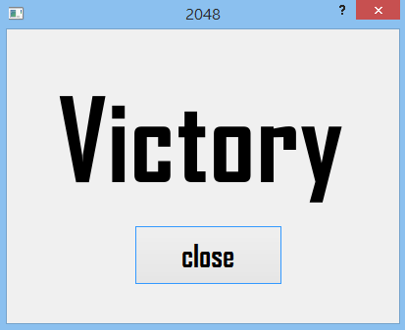

The UML class diagram

|  |
| --- |
| MainWindow |
| -q:play |
| -on_pushButton_clicked()  -on_pushButton_2_clicked() |

|  |
| --- |
| gameover |
|  |
| -on_pushButton_clicked() |

|  |
| --- |
| play |
| -map[4][4]:int  -check[4][4]:int  -score:int  -c:int  -A:int  -S:int  -W:int  -D:int  -pic[4096]:QPixmap  -g:gameover  -z:win |
| +keyPressEvent(QKeyEvent *press)  +setlabel(i:int,j:int,k:int)  +startmap()  +setmap()  +A_move()  +S_move()  +W_move()  +D_move()  +chk()  -on_pushButton_clicked()  -on_pushButton_2_clicked() |

|  |
| --- |
| win |
|  |
| -on_pushButton_clicked() |